1. ANITIBIOTIC

**Antibiotics, also known as antibacterials, are medications that destroy or slow down the growth of bacteria.**

They include a range of powerful drugs and are used to treat diseases caused by bacteria.

Infections caused by viruses, such as colds, [flu](https://www.medicalnewstoday.com/articles/15107.php), most coughs, and [sore throats](https://www.medicalnewstoday.com/articles/155412.php) cannot be treated with antibiotics.

In this article, we will explain what antibiotics are, how they work, any potential side effects, and discuss antibiotic resistance.

Fast facts on antibiotics

Here are some key points about antibiotics. More detail and supporting information is in the main article.

* Alexander Fleming discovered [penicillin](https://www.medicalnewstoday.com/articles/216798.php), the first natural antibiotic, in 1928.
* Antibiotics cannot fight viral infections.
* Fleming predicted the rise of antibiotic resistance we see today.
* Antibiotics either kill bacteria or slow its growth.
* Side effects can include [diarrhea](https://www.medicalnewstoday.com/articles/158634.php) and feeling sick.

**What are antibiotics?**

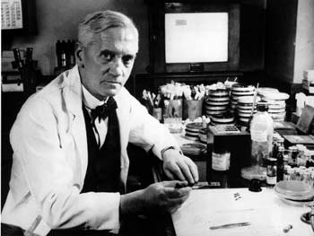  
*Alexander Fleming discovered penicillin in 1928.*

Antibiotics are powerful medicines that fight certain infections and can save lives when used properly. Antibiotics either stop bacteria from reproducing or destroy them.

Before bacteria can multiply and cause symptoms, the body's immune system can usually kill them. Our white blood cells attack harmful bacteria and, even if symptoms do occur, our immune system can usually cope and fight off the infection.

There are occasions, however, when it is all too much, and some help is needed; this is where antibiotics are useful.

The first antibiotic was penicillin. Such penicillin-related antibiotics as ampicillin, amoxicillin, and benzylpenicillin are widely used today to treat a variety of infections - these antibiotics have been around for a long time.

There are several [types of modern antibiotics](http://www.nhs.uk/conditions/Antibiotics-penicillins/Pages/Introduction.aspx), and they are only available with a doctor's prescription in most countries.

**Resistance**

There is concern worldwide that antibiotics are being overused. This overuse is contributing toward the growing number of bacterial infections that are becoming resistant to antibacterial medications.

According to the CDC (Centers for Disease Control and Prevention), outpatient antibiotic overuse in the United States is a particular problem [in the Southeast](https://www.cdc.gov/hai/surveillance/ar-patient-safety-atlas.html).

The ECDC (European Centre for Disease Prevention and Control) says that antibiotic resistance continues to be a serious public health threat worldwide. In a statement issued in [November 2012](http://ecdc.europa.eu/en/press/press%20releases/european-antibiotic-awareness-day-2011.pdf), the ECDC informed that an estimated [25,000](http://ecdc.europa.eu/en/publications/Publications/0909_TER_The_Bacterial_Challenge_Time_to_React.pdf) people die each year in the European Union from antibiotic-resistant bacterial infections.

New ECDC data shows that there has been a considerable increase over the last few years of combined resistance to multiple antibiotics in *E. coli* and *Klebsiella pneumoniae* in over one-third of European Union and EEA (European Economic Area) nations.

Consumption of carbapenems, a major class of last-line antibiotics, [increased significantly](https://www.ncbi.nlm.nih.gov/pubmed/22894617) from 2007 to 2010.

Alexander Fleming, speaking in his Nobel Prize acceptance speech in 1945 said: "Then there is the danger that the ignorant man may easily underdose himself and by exposing his microbes to non-lethal quantities of the drug, make them resistant."

As predicted, almost 70 years ago by the man who discovered the first antibiotic, drug resistance is upon us.

**How do antibiotics work?**

Although there are a number of different types of antibiotic, they all work in one of two ways:

* A bactericidal antibiotic (penicillin, for instance) kills the bacteria; these drugs usually interfere with either the formation of the bacterium's cell wall or its cell contents
* A bacteriostatic stops bacteria from multiplying

**Uses**

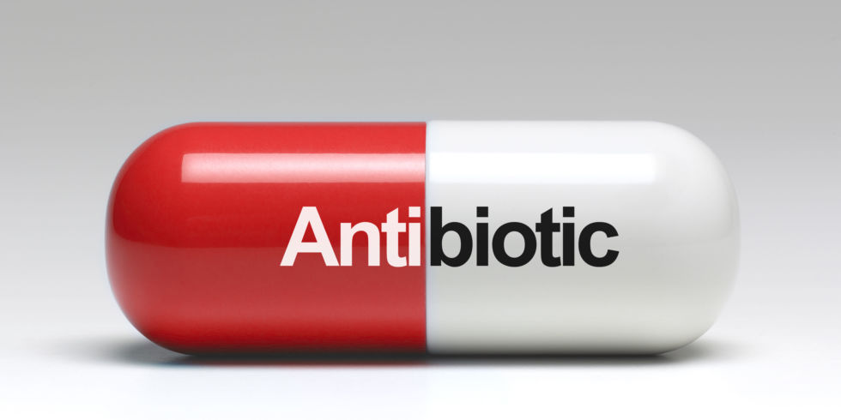  
*Antibiotics do not work against viruses.*

An antibiotic is given for the treatment of an infection caused by bacteria. It is not effective against viruses.

If you have an infection, it is important to know whether it is caused by bacteria or a virus.

Most upper respiratory tract infections, such as the common cold and sore throats are [caused by viruses](http://www.nhs.uk/Conditions/Respiratory-tract-infection/Pages/Introduction.aspx) - antibiotics do not work against these viruses.

If antibiotics are overused or used incorrectly, there is a risk that the bacteria will become resistant - the antibiotic becomes less effective against that type of bacterium.

A broad-spectrum antibiotic can be used to treat a wide range of infections. A narrow-spectrum antibiotic is only effective against a few types of bacteria. Some antibiotics attack aerobic bacteria, while others work against anaerobic bacteria. Aerobic bacteria need oxygen, anaerobic bacteria do not.

In some cases, antibiotics may be given to prevent rather than treat an infection, as might be the case before surgery. This is called 'prophylactic' use of antibiotics. They are commonly used before bowel and orthopedic surgery.

**Side effects**

Below is a list of the most common side effects of antibiotics:

* Diarrhea
* Feeling sick
* Fungal infections of the mouth, digestive tract, and vagina

Below is a list of rare side effects of antibiotics:

* Formation of [kidney stones](https://www.medicalnewstoday.com/articles/154193.php) (when taking sulphonamides)
* Abnormal blood clotting (when taking some cephalosporins)
* Sensitivity to sunlight (when taking tetracyclines)
* Blood disorders (when taking trimethoprim)
* [Deafness](https://www.medicalnewstoday.com/articles/249285.php) (when taking erythromycin and the aminoglycosides)

Some patients, especially older adults, may experience inflamed bowels (a type of colitis), which can lead to severe bloody diarrhea. Clindamycin, an antibiotic used for the most serious infections, commonly has this side effect.

Penicillins, cephalosporins, and erythromycin can also produce this side effect, but it is much rarer.

**Allergy**

Some patients may develop an allergic reaction to antibiotics - especially penicillins. Side effects might include a rash, swelling of the tongue and face, and difficulty breathing.

Allergic reactions to antibiotics can be [immediate or delayed hypersensitivity](https://www.ncbi.nlm.nih.gov/pmc/articles/PMC2846744/) reactions.

Anyone who has an allergic reaction to an antibiotic must tell their doctor and/or pharmacist. Reactions to antibiotics can be very serious, and sometimes fatal - they are called anaphylactic reactions.

Antibiotics should be used with extreme caution for the following individuals:

* Anyone with reduced liver or kidney function
* Anyone who is pregnant
* Anyone who is breastfeeding

**Interactions**

Individuals taking an antibiotic, should not take other medicines or herbal remedies without speaking with a doctor first. OTC (over the counter, non-prescription) medicines might also interact with antibiotics.

Penicillins, cephalosporins, and some other antibiotics can undermine the effectiveness of oral contraceptives. If the antibiotic has caused diarrhea/vomiting the absorption of contraceptives may also be disrupted. Anyone taking these drugs should consider taking additional contraceptive precautions.

**How to use**

Antibiotics are usually taken by mouth (orally); however, they can also be administered by injection or applied directly to the affected part of the body.

Most antibiotics start having an effect on an infection within a few hours. It is important to complete the whole course of medication to prevent the infection from coming back.

Stopping taking the medication before the end of the course means that there is a higher chance the bacteria will become resistant to future treatments. This is because the ones that survive have had some exposure to the antibiotic and may consequently have built up a resistance to it. Even if an individual feels better, they still need to complete the course of treatment.

Some antibiotics should not be consumed with certain foods and drinks. Others should be taken on an empty stomach - these would normally be taken about an hour before meals, or 2 hours after. It is crucial that patients follow the instructions correctly for the medication to be effective. People taking metronidazole should not consume alcohol.

Dairy products should not be consumed when taking tetracyclines, as they might affect the absorption of the medication.